Final Project Report

Student Name: Muhammad Ikmal Bin Ishak
Student ID: 2023313247

Project Name : Programmers Reality

1. Briefly describe the project purpose:

2. Draw the logic flow of the program (with flowchart):

3. Provide screenshots for each screen with brief description:

4. Explain the code of the main functionalities

5. Explain what is included in your project and why it is used (Polymorphism, Inheritance, File I/O, etc)

You can add more sections based on your project.

- PROJECT PURPOSE

The reason why I chose to make this game is because the game it is quite complex and interesting where u need to make your choices and if you made wrong choices you either lose the game or your status would be decreasing. The other purpose is to make the player to explore many endings and if they are lucky, they can reach secret ending. The project is also quite challenging to me because I need to do as many a scenarios for the user to choose so that the game kept longer and I tried to keep the game running in one frame so that it would lessen the pop out of another frame in order for you to keep playing.

- FLOWCHART (LOGIC FLOW) IF YOU MADE THE RIGHT CHOICE

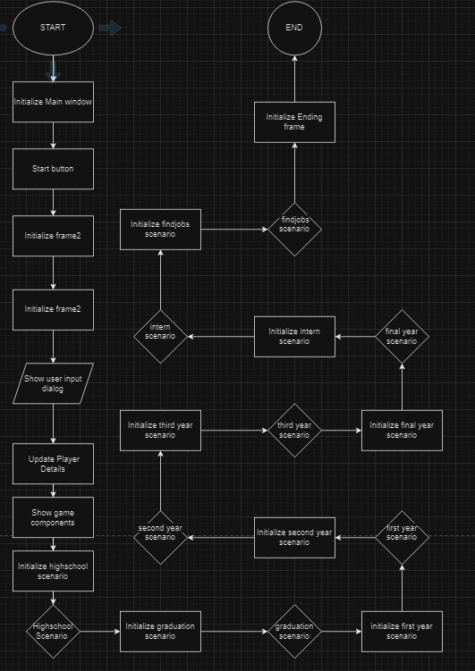

- SCREENSHOTS WITH BRIEF EXPLANATION
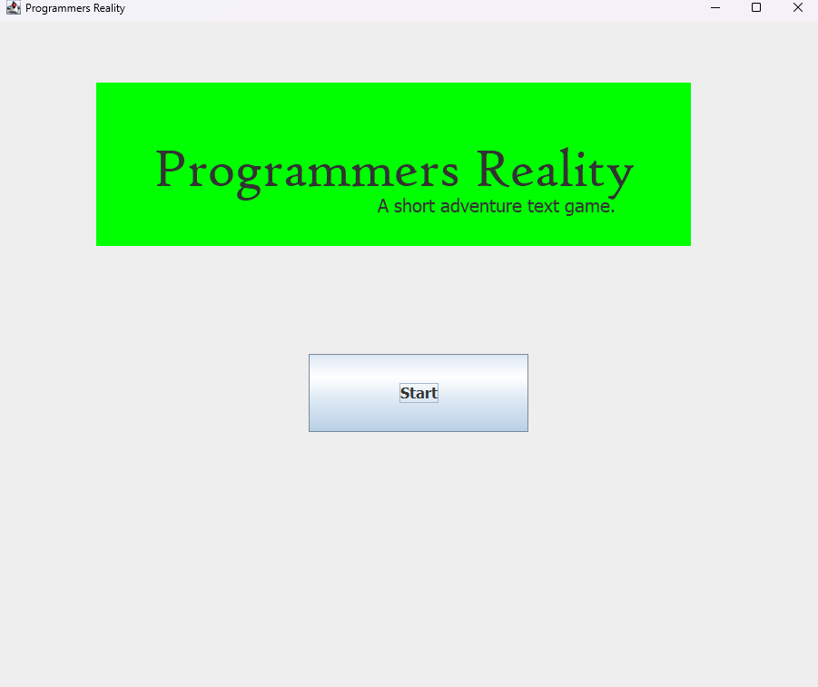
Main screen ( to start the game )

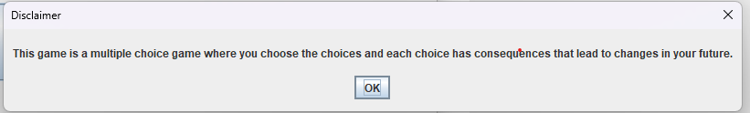
Disclaimer message (Just to tell you how to play this game)
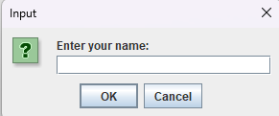
Name and gender popup( Enter your name as a player and to create your character)
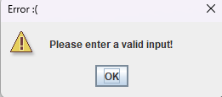
No name input error
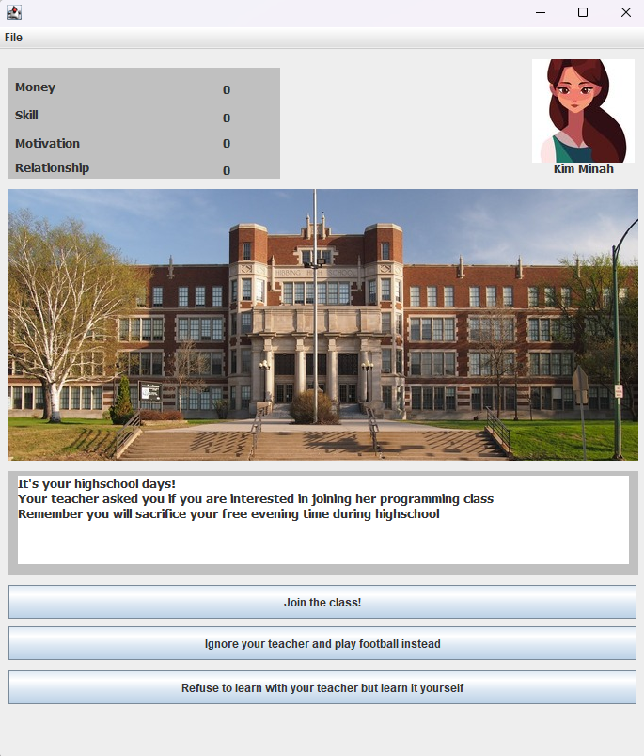
Highschool scenario(Make choices for your time in high school)
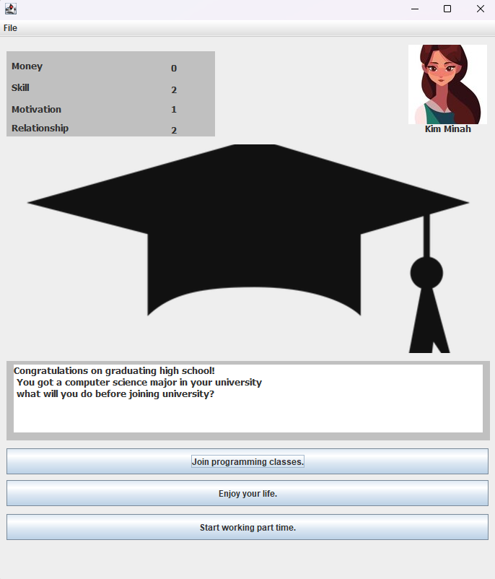
Graduation scenario(Make choices for your time after high school graduation)

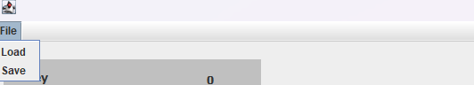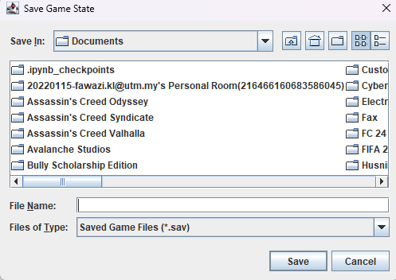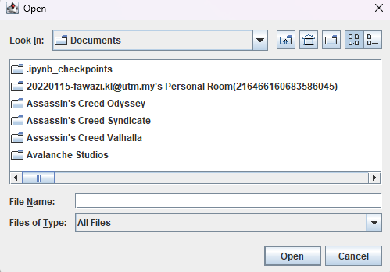
Save game option and load option
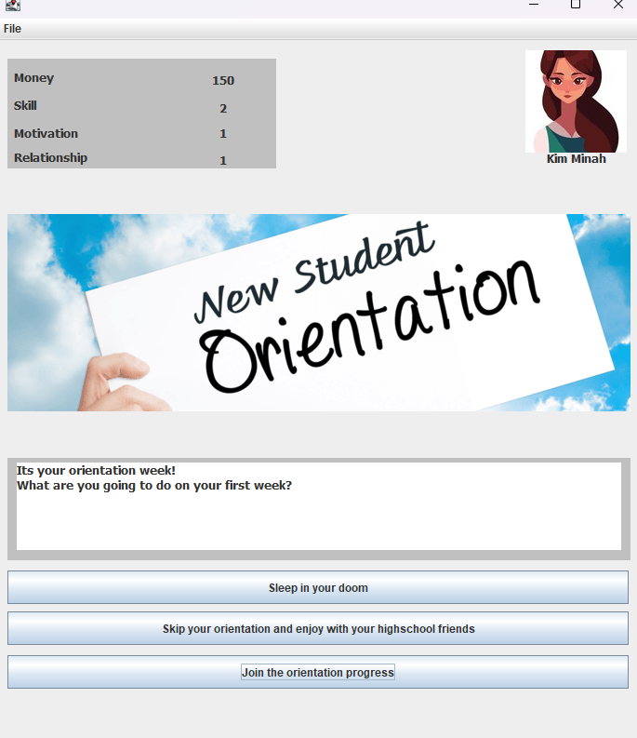
Orientation Scenario (Make choice for your orientation week)
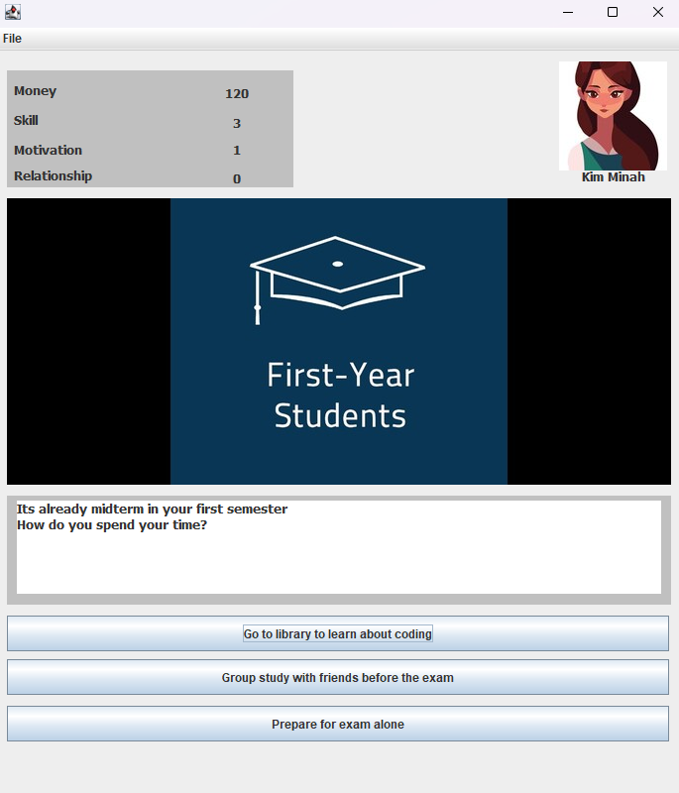
First Year Scenario (Make choice for your first year activities)
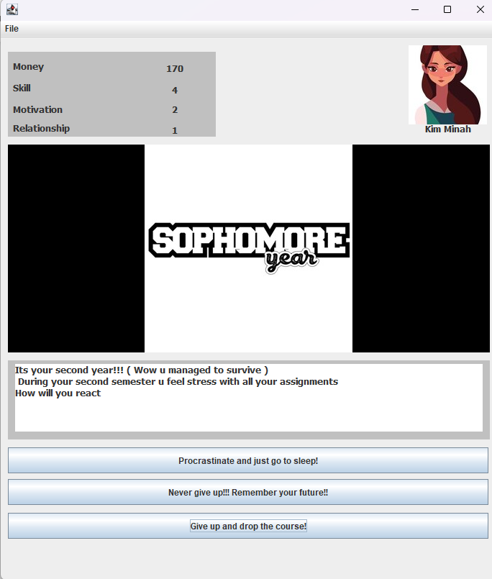
Second year Scenario
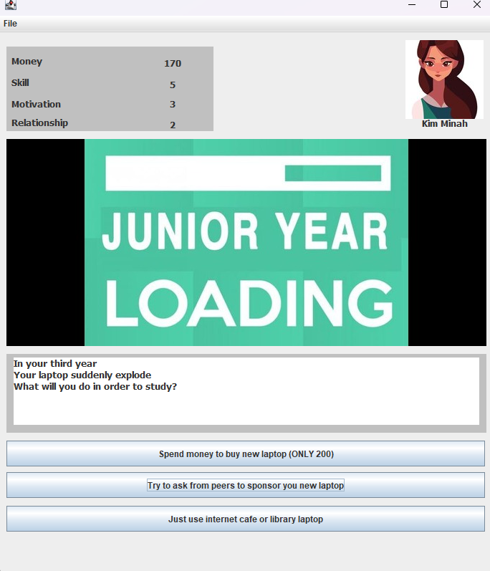
Third Year scenario

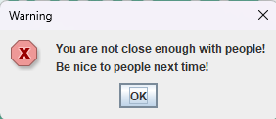
Choice blocked or choice not blocked (If your stats is too low to choose this stats it would be blocked)
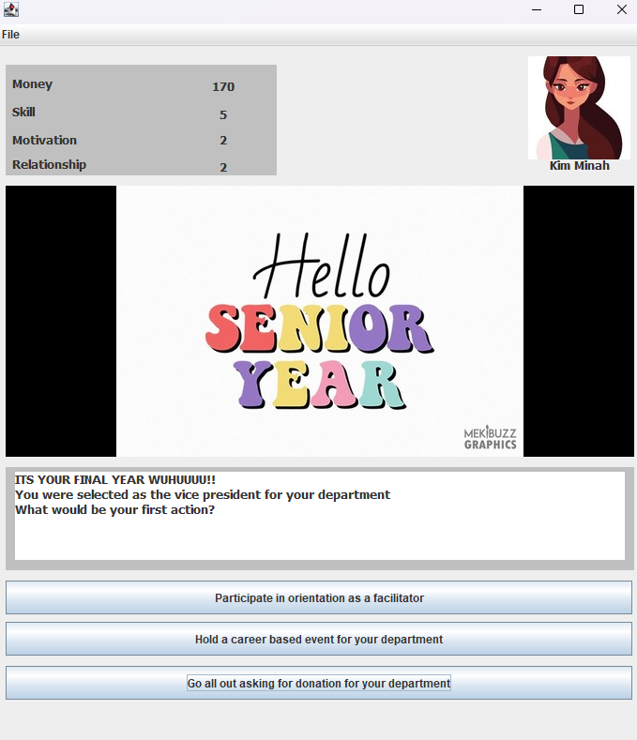
Final year scenario


Random lucky events!

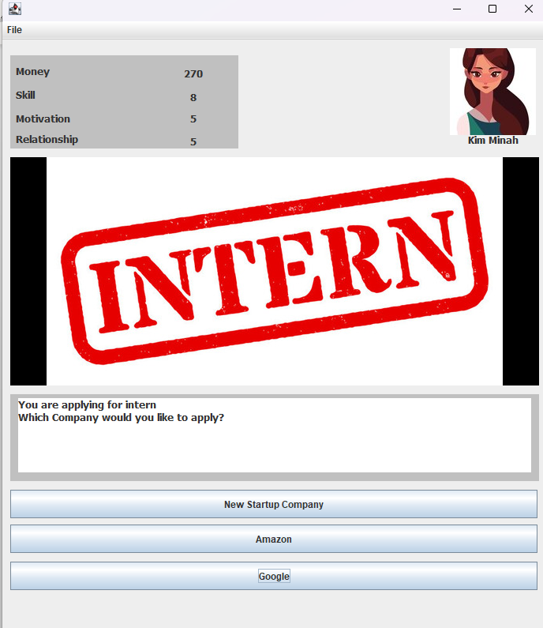
Intern scenario

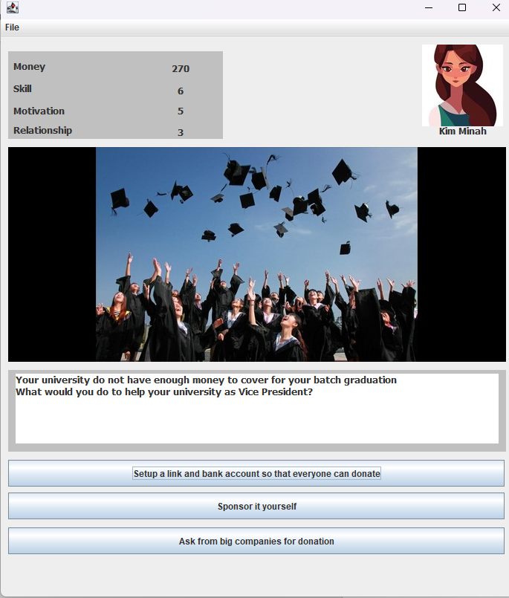
Graduation University scenario
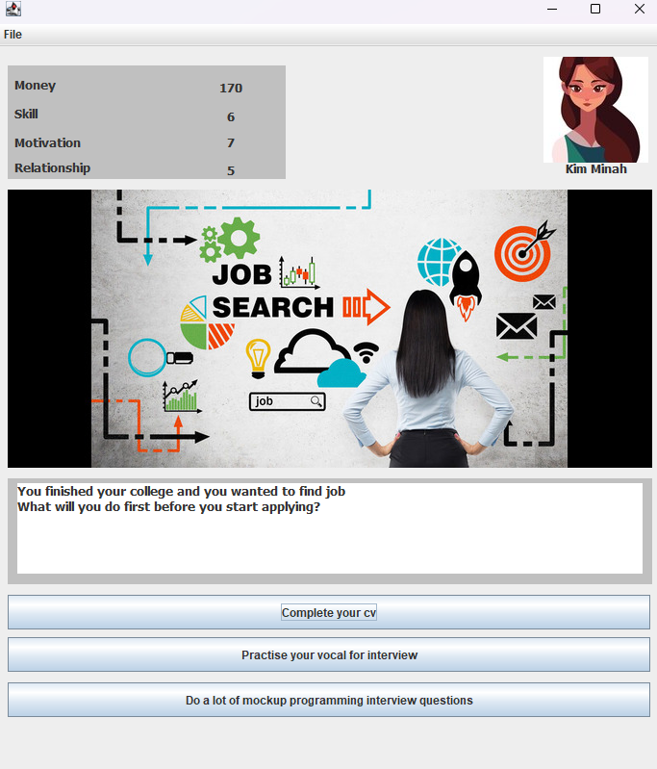
Find job scenario

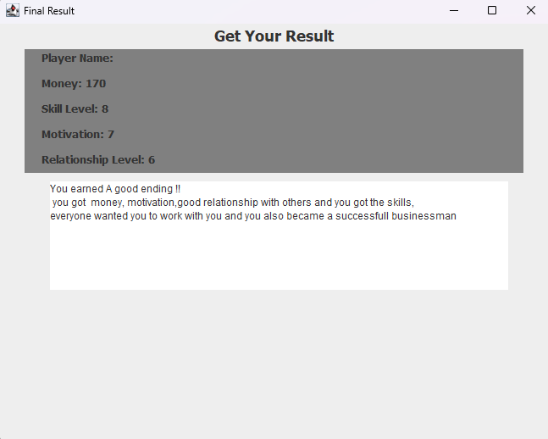Result Frame

- What is included
Present: Inheritance (frame2 extends JFrame), Interface (ScenarioTransition), File I/O (saveGameState() and loadGameState()), Encapsulation (in Player class), Exception Handling for I/O.

my frame2 class extends JFrame, demonstrating inheritance. This is shown in public class frame2 extends JFrame.

File I/O operations are present in the methods saveGameState() and loadGameState() in frame2 class. These methods handle saving and loading game states to/from files using JFileChooser and GameFileHandler.
Encapsulation:

Encapsulation involves bundling the data (attributes) and methods that operate on the data into a single unit (class), controlling access through modifiers (like private, public). MyPlayer class encapsulates the player's attributes (name, gender, money, etc.) and provides getter and setter methods to access and modify these attributes.
Interface:

ScenarioTransition interface defines several transition methods (transitionToGraduationScenario(), transitionToOrientationScenario(), etc.) which are implemented in frame2 class. Interfaces in Java define a contract for classes to implement certain methods.
Swing Worker:

Exception handling related to I/O operations is demonstrated in saveGameState() and loadGameState() methods where IOException is caught and appropriate error messages are displayed using JOptionPane.

GUI of course is used properly.

